June 12th, 2011
Hi
HAPPY BIRTHDAY NADINE

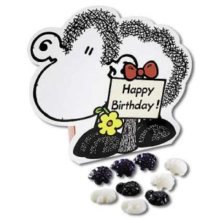
Happy birthday for today (Sunday). Take your choice of birthday cards.




Last Monday was the Tuen Ng - dragon boat - holiday. Again, I was unaware that it was a holiday until later in the day. There were many dragon boat races around HK that day. The number of races and boats taking part seem to be increasing every year.
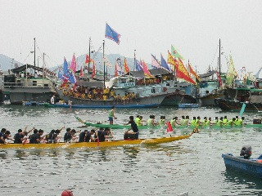
There are different findings about the origin of Tuen Ng. The mostly widely accepted one is about a patriotic scholar-statesman Chu Yuan who drowned himself in 288 BC to protest against the emperor. Chu Yuan worked very hard to offer good counsel to the emperor but the emperor wouldn't listen. The people respected Chu Yuan and when they heard that he had drowned, they jumped into boats to search for him. This is a part of what the Dragon Boat Festival commemorates every year. Failing to find him, the people hit drums to make a loud noised hoping to scare the fish and prevent them from touching his body. Also, people living alongside the river put cooked rice in the river as a sacrifice. But then they found that the fish got the rice so they started to wrap the cooked rice in bamboo leaves. This evolved into today's rice dumplings.
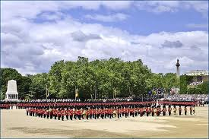
If HK had still been a British colony, this would have been the Queen's (official) birthday weekend. In the UK – and Australia (as I saw on their TV news last night) – it is celebrated every year by the “Trooping the Colour” (colour = flag), a ceremony that dates from the time of Charles II in the 17th Century when the colours of a regiment were used as a rallying point in battle and were therefore trooped in front of the soldiers every day to make sure that every man could recognise those of his own regiment. For more, if you are interested:
http://www.trooping-the-colour.co.uk/
The Duke of Edinburgh also turned 90. Pretty sprightly for his age.
Did three swims again this past week. By Friday afternoon, I was very tired – exhausted in fact. But I guess I will continue with exercise this week.
That seems to be it for now. Had it not been for the comments on the two holidays, it would have been a very short letter.
Cheers

